Interface Specification
Skullduggery
Greg Baker - Robert Koeninger
Advisor: Prof. Wilsey
Jan 13, 2010
Revised: May 11, 2010

Introduction
The application is being written for the Skullduggery project, which will suppliment the GSM encryption that is currently the standard. The application will have one UI component. The application will have a text field for entering the valid phone number, a text area for displaying error messages and other phone status information, and two buttons for controlling the call state.
The two buttons will be labeled call and hangup. The call button will initiate a call to the number specified in the text field. The hangup button will terminate a call in progress.

Before the call
The application will wait for an incoming connection when started, or for user input to connect to an external phone. The hangup button will be disabled.

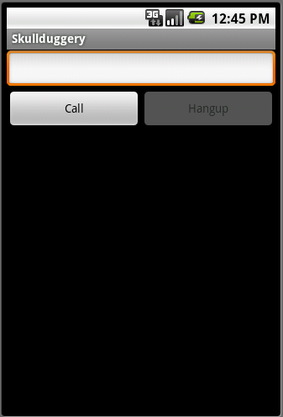Fig 1: The interface upon opening the Skullduggery application

During the call
The display during the call will be changed to convey the status of the call. If the call is safely encrypted, a message informing the user that the connection is secure will be displayed. If the call is not safely encrypted, the call will be terminated. After the call is finished, the application resumes the same state as before the call. In this state, the call button is disabled, and the hangup button is enabled.
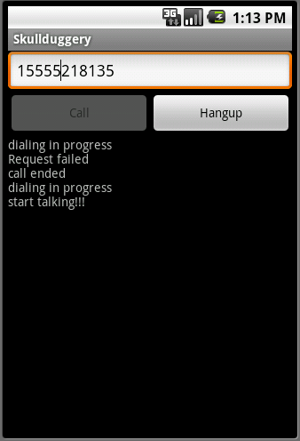Fig 2: A call in progress

